

**Open Access Electricity Sourcing Optimization**

**By using Data Analytics**

**Submitted by**

**Happiest Minds Technologies**





**Copyright Information**

This document is the exclusive property of Happiest Minds Technologies Ltd. (“Happiest Minds”). The recipient agrees that they may not copy, transmit, use, or disclose the confidential and proprietary information in this document by any means without the expressed and written consent of Happiest Minds. By accepting a copy, the recipient agrees to adhere to these conditions to the confidentiality of Happiest Minds practices and procedures.

**Confidentiality Clause**

This document is being submitted MSIL by Happiest Minds Technologies Ltd. on the understanding that the contents of this document will not be divulged to any third party without the express written consent of the parties. It is understood that the parties will not divulge any confidential information about MSIL that it may have access to during this interaction.

**Disclaimer**

This document has been prepared based on the information provided by MSIL. Wherever proposed, the solutions and/or services mentioned are based on the requirements defined and understood by us at the time of preparing this document. While every effort has been made to make this document as accurate as possible, there might be changes to the document based on the subsequent discussions.

1. Executive Summary 4

2. Our Value Proposition To MSIL 5

Pedigree of building AI & Data platforms of excellence to time & budget with embedded Privacy by design 5

Our Product Engineering Pedigree 5

3. Project Summary 6

BACKGROUND 6

Business Requirements 8

4. Our Understanding Of Business Need 8

Functional Requirements 8

AS-IS Process 8

Current Business Logic for IEX Power Quantity for Bidding: 9

Current Business Logic for IEX Power rate for Bidding: 9

TO BE Process 9

Proposed Business Logic for IEX Power Quantity for Bidding: 9

Proposed Business logic for IEX Power rate for Bidding: 10

Proposed Business logic to check system accuracy more than 90%: 10

Business Rules: 10

Functional View: 10

In Scope 11

Out of Scope 11

5. Proposed Solution 11

Solution Architecture 11

Technology Stack (indicative) 13

Testing and Validation 13

6. Assumptions & Dependencies 13

Assumptions 13

Dependencies on MSIL 14

7. Project Governance 15

Project Delivery Approach 15

Governance Model 16

Execution schedule 16

Change Management 17

Acceptance criteria 18

8. Commercials 19

9. Intellectual Property Rights 19

1. Executive Summary

Happiest Minds would like to thank MSIL for giving us this opportunity to bid for this RFP for the energy usage optimization from various options available. MSIL intends to build a forecasting solution for demand forecast from plant needs and supply forecast for solar energy production and accordingly big energy from IEX by forecasting it’s price and optimize between green and brown energy bidding with use of AI and emerging technologies.

As we understand, MSIL wants to improve the process of bidding electricity which will optimize their bidding among green and brown energy, it would save cost and help MSIL to align to ESG and low carbon footprint goals. As of now, data analysis and bid plan creation are manual processes, which are not optimal. It’s the MSIL endeavor to ensure that IEX bidding is done to save costs and expensive resources like gas turbine for power generation are least used.

MSIL has various business goals such as top-line growth and bottom-line optimizations. With the vision to become a data driven enterprise, MSIL would be utilizing advanced technologies such as analytics platforms, AI, and cloud to manage business problems like intelligent forecasting, business decision making, optimizations and revenue improvements. We also understand that MSIL is looking at achieving its vision in multiple phases.

Based on our experience of having collaborated with multiple customers in a similar domain, we believe that there are a few critical attributes which need to be present in an ideal partner and are critical to the success of such projects. Our value proposition section 2 will direct you to the critical attributes of happiest minds aiding success.

*Happiest Minds is excited to bid for this RFP from MSIL and we believe that Happiest Minds is well placed to be the partner of choice for MSIL.*

1. Our Value Proposition To MSIL

We have put together our proposal keeping in mind MSIL requirements and vision. Some of the key tenets of our expertise which we will bring to this engagement and that we have highlighted as part of the proposal are:

* **Compelling expertise in Industrial and Automotive** 
  + **Multiyear engagement with many Industrial and automotive for:**
    - Developing Data platform
    - Multiple forecasting solutions such as campaign success, campaign driven demand forecasting
    - Predictive maintenance
    - Business decision support with effective analytics and visualization
    - Customer360 for better value-based-care and marketing-offer creation.
    - Customer experience, personalization/recommendations
  + **Across multiple domains:**
    - Sales analytics, demand forecasting and recommendations
    - Pricing analysis
    - Product analysis
    - Customer feedback analysis
    - Competitor analysis
    - Scoring on e-commerce websites
    - Brand score
    - Churn analytics and performance management
    - Auto feedback analysis
    - Auto short answer grading
    - Chatbots
    - Real-time customer pain-addressing for better customer experience.
    - Ad-Sales analysis
    - Customer journey improvement
    - Highlight generation

**Strong experience in leveraging Data analytics and AI/ML capabilities** to address similar use cases. We have Analytics CoE which brings in excellence required.

Pedigree of building AI & Data platforms of excellence to time & budget with embedded Privacy by design

Happiest Minds leverages disruptive technologies for business model changes – technologies such as Cloud, Mobility, AI, Big Data & Analytics, Social Computing, Security and IoT. We have not deviated from that singular focus since inception for which we have been recognized by analysts (IDC, Zinnov, Forrester, Frost & Sullivan) as leaders in Digital and related technologies/capabilities.

Our Product Engineering Pedigree

We come with rich Product Engineering experience wherein we have been working closely with our customers/partners to build products, solutions, and experiences. Our Product Engineering Services BU aims to help our customers capitalize on the transformative potential of ‘digital’ by building products and platforms that are smart, secure, and connected. We provide our customers with a blend of hardware and embedded software knowledge which combines with our software platform engineering skills to help create high quality, scalable and secure solutions. Our offerings extend across the development lifecycle from strategy to final roll out while ensuring quality.

1. Project Summary

Background

We understand MSIL is looking to build a system that can help them in buying electricity using IEX platform in much competitive rates, by forecasting optimal bid quantity & rate, and predicting optimal use of brown & green power to meet targets. The system bidding success rate should be more than 90% for electricity sourcing bidding. Currently Maruti plant load is managed by 3 sources of electricity i.e., government power (DISCOMS), Solar Power (Inhouse) & Captive Power (Gas Turbine). On occasional basis Maruti has to buy electricity using IEX platform to meet the government obligations, CO2 reduction & cost reduction. Maruti has annual targets to buy green & brown energy using IEX platform, once that target achieved, Maruti stop bidding on IEX platform.

Electricity Sourcing Ecosystem

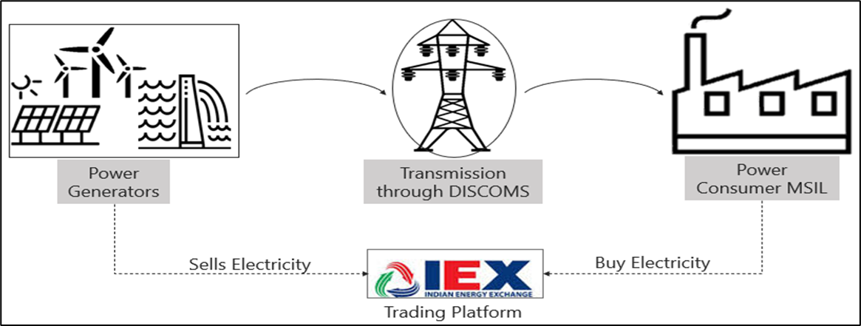

**Power Generators:** These are companies who produce electricity.

**DISCOMS:** These are distribution licensee who are authorized to sell electricity in their respective area.

**Power Consumers:** These are the end users who consume power for their purposes.

**Indian Energy Exchange (IEX):** It’s a trading platform which allows power producers and consumer to sell & buy power as per their need.

* The government allows electricity producers and consumers to directly buy & sell power in the open market by using the IEX platform.
* Consumer companies listed on IEX platform must forecast their next day load with IEX and authorized body (DISCOMS), so that DISCOMS can reduced that load from sanctioned load for next day.
* The interest of the producers is to sell the power at a higher rate and interest of consumer is to buy a power at cheaper rate.
* When the interest of both parties meets, then electricity trading happens, and distribution of power is done by DISCOMS only.

Distribution of Bid Area on IEX

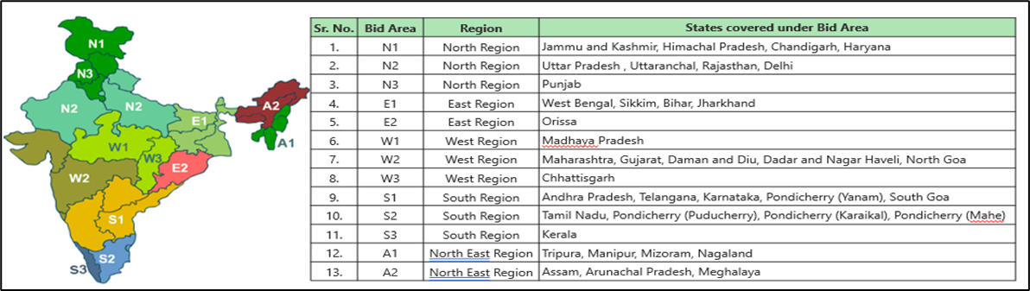**Key Points**

* The country has been divided into 13 bid areas for the purpose of calculating prices in Power Exchange.
* A closed double-sided anonymous auction for each 15-min time block for the day.
* For DAM trading there are a total of 96 slots available on IEX platform to bid for the next day, each slot 15 mins duration.
* In case of congestion, when the required flow exceeds transfer capability, congestion management is done through market splitting.
* In Marketing splitting, the price is reduced in the surplus bid area (sale > purchase) and increased in the deficit area (purchase > sale).
* For Maruti, refer N1 area on IEX platform for bidding, as Maruti plants lies in that area.

How Day Ahead Market (DAM) Operates on IEX

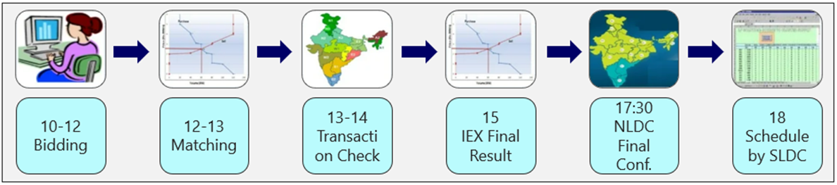

1. Bidding initiates on IEX platform between 10-12 PM for 15mins block slots. During this time consumers can do all the entry & modification work.
2. Matching of the bids takes place based on Market clearing price (MCP) & marketing clearing volume (MCV) between 12:00-13:00 and sends final provision to National Load Dispatch Center (NLDC).
3. The NLDC checks the transactions & congestion period between 13:00-14:00 and informs IEX in case of congestion.
4. IEX recalculates area clearing price (ACP) & area clearing volume (ACV) in case of congestion & sends final schedule to NLDC at 15:00.
5. NDLC sends final confirmation to IEX at 17:30 and IEX sends files to State load dispatch center (SLDC).
6. SLDC incorporates final the schedule at 18:00.

Business Requirements

The objective is to design software to:

* forecast the optimal bid quantity for the next day
* forecast the optimal bid rate for the next day
* increasing the bid success rate to greater than 90%
* to optimize the use of brown and green power to meet targets

1. Our Understanding Of Business Need

Based on the BRD from MSIL and clarification discussions our understanding is that we have a total of 3 types of energy sources: 1. Govt power 2. Solar plant in Manesar 3. Gas turbine (should be used least for fail safe only).

For handling above power sources and optimizing usage for cost reduction and green target meeting, few prediction and optimizing modules need to be created. MSIR want to have demand side forecasting with plant power consumption forecasts and want to create supply side forecasting which is on solar generation forecast for Manesar plant and IEX side price forecasting.

MSIL would also like to optimize the IEX bidding by calculating break-even costs based on rates from govt power and settling charges on IEX. There are overdrawn charges from govt power which are very high, and under drawl charges which are lesser & manageable. The IEX power is to be purchased only when the total cost of buying from IEX is less or equal to govt power.

Functional Requirements

As stated above, in the previous section, MSIL is looking to buy the power through IEX platform at competitive price with 90% success rate of bidding. To meet the mentioned requirement the following points, need to be addressed:

1. Prediction of Inhouse solar plant output for next day.
2. Predict plant load for the next day.
3. Forecast bid quantity for every 15 mins slot for IEX platform.
4. Prediction of rate at IEX platform for every 15 mins slot and corresponding bid rate for that time slot, considering forecast bid rate should not exceed the breakeven rate.
5. 90% should be success rate of bidding, for IEX platform & the bid we win against that.
6. Output of the system should come in excel file only.
7. In the later phase the system must tell the distribution between green & brown power procurement.

AS-IS Process

* MSIL creates IEX power sheet on daily basis where they enter bid quantity & rate for every 15 mins slots.
* MSIL shares an IEX power sheet with consultant for bidding & with DISCOMS for next day load planning.
* Result of the bidding are received to MSIL by 4:00 pm on daily basis.
* MSIL must plan the plant load basis of bid result, as in case an over drawn case, MSIL has to pay the high penalty to the government.

TO BE Process

* The system will create IEX power sheet on a daily basis, which predicts bid quantity & rate for every 15 mins slots.
* MSIL share system generated IEX power sheet with consultant for bidding & with DISCOMS for next day load planning.
* More than 90% of bids should be accepted by IEX with respect to the IEX portal rate prediction when result received to MSIL at 4:00 PM.
* MSIL must plan the plant load basis of bid result, as in case of over drawn case, MSIL must pay the high penalty to the government.

### Business Rules

1. MSIL does not quote rate more than breakeven cost as explained above.
2. MSIL does not bid between 7:00 AM to 6:00 PM as there are more chances to get solar power from IEX.

### Functional View

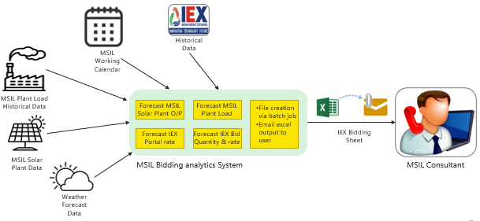

In Scope

* Create script-based logic to identify forecasting of energy.
* As per our understanding, there is a research component to solar forecasts where earlier trials by MSIL with solcast-APIs have not yielded good results. Hence, it is advisable to run this project in a stepwise manner with Phase-1 and Phase-2. We can scope it into 2 Phases:
* **Phase 1 (only Solar forecast)**
  1. Solar energy forecast based on weather data with historical weather data and corresponding solar production.
  2. Try the best possible 2-3 methods for better solar forecasts, it involves R&D where committing accuracy is not possible.
* **Phase 2 (Plant load forecast + IEX price and quantity forecast + Optimization between green & brown energy)**
  + Take care of all other aspects such as plant demand forecast, IEX price prediction and volume to bid and analysis of brown vs green power.
  + Predicting the Plant load data taking into consideration the plant load patterns and holiday calendar.
  + Analysis of the Historical IEX settlement rates and government charges, fees, transmission losses data etc.
  + Analysis of the brown power and green power bidding to optimize cost savings as well as CO2 reduction targets.

Note: Phase 2 will be started only if phase-1 gives good results. Accuracies from Solar are subject to experimentation.

Out of Scope

1. UI & Middleware, APIs
2. Infrastructure Automation is not included
3. CICD Pipelines is not a part of deployment.
4. API Gateways not part this.
5. AWS account creation to be done by Maruti team.
6. Any License and Domain purchase done by Maruti team.
7. Infrastructure and application Monitoring and alerts
8. Application login and authentication
9. Visualizations and dashboards
10. UAT
11. MLOps
12. Proposed Solution

Solution Architecture

The following is the high-level system architecture diagram for the Forecasting engine.

**Overall Flow* (After Phase 1 & Phase 2)**

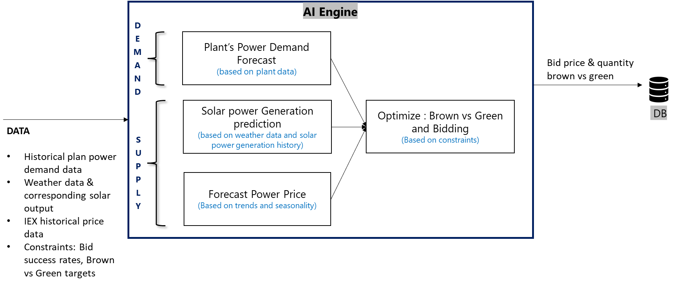

**Overall System Architecture**

*: For Phase 1: only Solar power generation prediction applicable

Some of the key modules are:

**Plant based Demand forecast**: this would be based on plant data; it may have multiple step pipeline to create model for prediction.

**Solar power Generation prediction**: Based on historical weather data and solar power generation, create a forecasting algorithm to predict solar power generation based on the weather forecast from an external service.

**Forecast Power price**: Forecast IEX power price based on trends and seasonality. The prediction should be per 15 minutes for the next day.

**Optimize: Brown vs green bidding**: Use demand forecast and supply forecast (solar power generation and IEX power price), make optimized plan on how much energy to buy from different sources.

**Forecasting Pipeline (Indicative)**

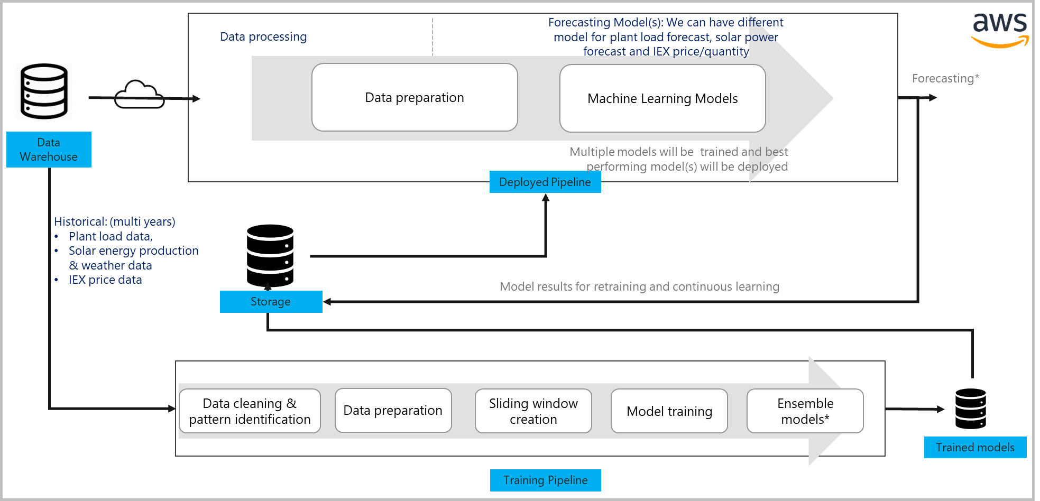

Forecasting*: In Phase-1 only solar energy forecast will be done, whereas in Phase-2 plant-demand forecast, IEX price next day and quantify to bid would be taken care with above indicative pipeline.

**Data Cleanup & Pattern identification:** Along with manual analysis, create scripts (as needed) to do data cleanup and imputation. Here we can understand how weather data impacts solar energy produce, is there any pattern in plant load, do we need holiday calendar to be used for plant load forecast, is there any pattern in IEX prices with different months, day/night, holidays etc.

**Data Preparation:** Create multiple features based on different use cases, this must go hand in hand with Data cleanup and pattern identification. Data preparation also involves understanding business problems along with stakeholders, it could be combination of standard techniques and business analysis based creative feature engineering.

**Sliding window creation:** For time series models to understand how prices, plant forecast, solar forecast has been in different windows

**Model training**: Train multiple machine learning models for different kinds of forecast, this may vary based on Phase-1 and Phase-2 in the proposal on how many models we train.

**Ensemble models:** Create ensemble of different machine learning models to get best accuracy.

Technology Stack (indicative)

|  |  |  |
| --- | --- | --- |
| **Feature** | **Technology** | **License/Subscription** |
| Cloud | AWS | MSIL to provide access |
| Storage | DynamoDB |
| Machine Learning | Python, Databricks, Spark, Sage maker |

Testing and Validation

In this scope of MVP, we are only looking to create script-based system, data scientists will do dev level validation of accuracies of models and MSIL team can do UAT based on results and reports.

1. Assumptions & Dependencies

Assumptions

|  |  |
| --- | --- |
| **Category** | **Details** |
| General | In case of scope change after project start, with mutual discussions we may go through change management. |
| Integration with any other ecosystem is out of scope, if any API like weather-forecast API for getting next day weather forecast, or IEX data live streams, will be provided by MSIL. We can use these APIs as part of our algorithm-pipelines. |
| MLOps is out of scope, but if needed MSIL can plan this activity with existing Happiest minds team working on MLOps. |
| AI – Algorithms | The accuracy of the model would improve as it matures. Accuracy would depend on the quality of the labeled data. However, machine learning systems do not guarantee 100% accuracy. Further, in this case accuracy of model can be with buffers as well, example in case of IEX price, if Rs. 3100 is the most optimal bid on IEX, but our breakeven price is Rs 3400(govt charges minus settlement charges), then even bid of Rs. 3200-3300 will be successful bid and spot-on for accuracy. |
| Forecasting and optimization models will be batch-based model and forecasting results will be emailed. |
| The algorithms described in block diagrams are indicative and for the starting point. After trials, we may have to tweak the algorithms. |
| Algorithm development would be based on tools like scikit, spark-MLLib, Tensorflow, etc. Focus would be on using the best of algorithm combinations, best tuning parameters, massaging data etc. Tweaking the internals of these libraries is not in the scope. |
| The model needs to see a significant amount of data (example >5% of total data size) for any data drift. |
| Data | MSIL team would be responsible for getting all data (example: Solar weather data and outcome, IEX rates for last few years, Plant load data for last few years) needed for forecasting in AWS-S3. |
| External data (example: Impact of war on power prices) beyond weather data and IEX data is not assumed for data analysis and forecasting in this phase. |
| No Data labeling effort is assumed in this scope. Example: For solar forecast: weather data and corresponding solar energy output(labels) will be provided by MSIL |
| Data quality is assumed to be good, if data quality (such as systematic/capturing errors, noisy data, inconsistency etc.) is bad, it may affect model’s accuracy. |
| Data required for the dashboard has been ETL'ed and available for consumption |
| Quality Engineering | Testing and validation at each milestone/sprint by Happiest Minds and MSIL team |
| Environment | Dev and deployment environments will be provided by MSIL. |
| During the execution of the project the licensed software/cloud/GPU infrastructure will be provided by MSIL. Server requirement will be determined after trials |

Dependencies on MSIL

|  |  |
| --- | --- |
| **Item** | **To be available by** |
| Identification of MSIL’s stakeholders for the project & also MSIL’s success manager/Single SPOC, SME(s) for regular feedback and clarifications. | Start of the project |
| Required infra, access to AWS, Development, UAT etc. | Before development and UAT sprints |
| Datasets (in AWS for development & testing) | Start of the project |
| Scoping and requirements | During the planning stage |
| Feedback on requirement, algorithms | Within 3 business days of submitting the deliverables |
| Response to Happiest Minds queries | Within 2 business days of raising the query |
| Milestones deliverable approval | Within 3 business days of deliverable submission (Otherwise they will be deemed accepted) |
| Final milestone approval | Within 5 business days of milestone submission. Delays might result into Change Requests and increased cost |
| Review the UAT Test cases | Before start of UAT |
| UAT (If required) | As per plan sheet. We assume that UAT will be completed within 2 weeks of timeframe. |

# Project Governance

Project Delivery Approach

Agile Scrum framework would be used for project execution. Scrum ensures transparency in communication and creates an environment of continuous progress. The diagram below depicts the model followed by Happiest Minds in Agile projects.

2-weeks sprint cadence would be followed and there would be a demo/deliverable at the end of each sprint.

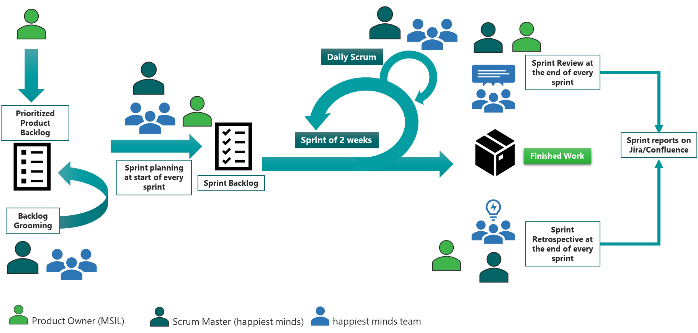

Governance Model

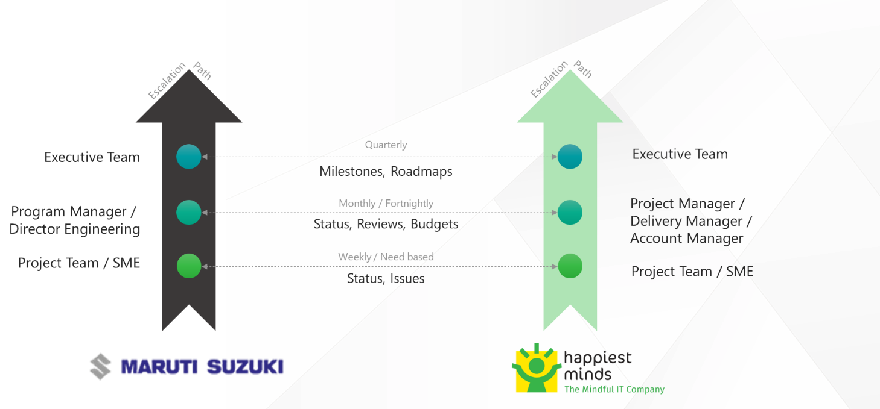

Project Communication Model

The communication model will involve the activities below for successful delivery of the project:

1. **Daily Standup meetings**: Between Offshore team and Project manager to discuss tasks completed, task planned and any outstanding blocking issues. MSIL is not required to participate in these meetings, but they are welcome to participate if they want to.
2. **Weekly Status Meeting**: Between Project manager at Happiest Minds and Project manager of MSIL to discuss weekly status report and next week’s plan, issues, risk on the on-going phase of the project.
3. **Monthly Operational Meeting**: Between Delivery Manager and Project Manager at Happiest Minds and Project sponsor at MSIL to discuss progress on the project, issues, and risk with resolution for project delivery and commercials.

Execution schedule

The delivery schedule is based on our current understanding of requirements. Any changes in scope of the project are expected to have an impact on the cost and schedule of the project. Following is an indicative plan for the implementation, a detailed one shall be arrived at within the 1st sprint of the project start and shared with all stakeholders.

**Phase 1: Execution Schedule for solar energy forecast**

**Assume Project Start Date: (T)**

|  |  |  |
| --- | --- | --- |
| **Milestones** | **Due Date in Weeks** | **Sprint Activities** |
| Project Kick off | T + 0 | * Kick off – on boarding |
| Discovery and Design Phase | T+2 | * Design and Data Analysis * Detailed plan |
| Milestone 1 | T + 6 | * First cut Forecasting engine for “solar energy forecast” |
| Milestone 2 | T + 8 | * Second cut Forecasting engine for “solar energy forecast” (another algorithm or improvements in first one) |
| Milestone 3 | T + 10 | * Improvement in solar energy forecast and ensemble (as needed) |
| UAT | T + 11 | * UAT (Carried by MSIL) * Bug Fixes |

**Phase 2: Execution Schedule**

**Assume Project Start Date: (T)**

|  |  |  |
| --- | --- | --- |
| **Milestones** | **Due Date in Weeks** | **Sprint Activities** |
| Project Kick off | T + 0 | * Kick off – on boarding |
| Discovery and Design Phase | T+2 | * Forecasting Engine architecture * Sprint planning |
| Milestone 1 | T + 8 | * First cut Forecasting engine for “plant load forecast”, and IEX price & quantity. |
| Milestone 2 | T + 12 | * Improving plant load forecast, implementation of IEX price and quantity forecast * Optimize logic first cut |
| Milestone 3 | T + 14 | * Business rules and fine tuning * Readme Document |
| UAT | T + 16 | * UAT (Carried by MSIL) * Bug Fixes * Documentation & KT |

***Note:*** *UAT should be completed within 2 weeks from the delivery of the system tested application. Any further time needed shall go through the change management process. A detailed sprint plan would be shared after the discovery & design phase*

*If required, phase-1 and phase-2 can be executed in parallel.*

|  |  |  |
| --- | --- | --- |
| **Warranty Support (Only Phase 2)** | | |
| **Activities / Tasks** | **Due Date in Weeks** | **Deliverables** |
| Bug fixes | T+18 weeks | Bug fix patch |

*Happiest Minds will provide a warranty of 2 weeks from the completion of UAT and during this period will address any P0 or P1 issues reported on the deliverables. Only defects shall be addressed during this period and any changes/enhancements shall go over the change management process. Post-warranty period, the deliverables are deemed as accepted*

Change REQUEST Management

Changes to the scope will mean any of the following:

* Change introduced in the application between the proposal and actual implementation or during the implementation.
* Any changes to the scope of the project as detailed in section “In Scope”
* Invalidation of any of the assumptions detailed in section “Assumptions”
* Any change to the terms and conditions as defined in section “Commercials”
* Non-fulfillment of any of the dependencies detailed in the sections “Dependencies”
* Any delay that happens to the schedule can be attributed to MSIL.

In case of a change request, the scheduled end date for this Project and/or the fees associated may change. Whenever a change is identified, it will be managed as per the below process:

* For any changes to the scope, either MSIL or Happiest Minds will submit a Change Request
* Happiest Minds will issue a Change Order providing the impact of the change to the schedule and/or fees
* MSIL SPOC will review along with Happiest Minds SPOC and mutually agree to either approve or cancel the change order
* Changes will be implemented only after MSIL SPOC approval and signing of the change order form by both the Parties
* For any MSIL dependencies that are not met or issues that are not resolved, which could impact the schedule – Happiest Minds Project Manager will complete a Change Order and inform the MSIL SPOC.

Acceptance criteria

* The user story’s acceptance criteria/test cases will be reviewed and mutually agreed upon.
* The Acceptance test case document along with acceptance test environment details would be shared by MSIL at least 6 weeks before the start of Acceptance Testing
* Acceptance Testing will be conducted by MSIL team and supported by Happiest Minds
* Acceptance Testing should be completed within 2 weeks from the delivery of the system tested application
* The acceptance criteria will be passing of the user acceptance test cases with Zero Critical (P0) and High (P1) severity bugs identified

**Defect Severity – Definition:** Definition of Defect Severity and Priority are as below.

|  |  |
| --- | --- |
| **Defect Severity** | **Definition** |
| P0 – Critical | Defect may be a showstopper – that is, it stops the user from using the system further. |
| P1 – High | Defect occurs repeatedly and prevent the user from proceeding in the normal way, but a workaround exists. |
| P2 – Medium | A defect is isolated or does not stop the user from proceeding but is annoying and causing inconvenience. |
| P3 – Low | A defect that in no way affects the performance or functionality. E.g.: Aesthetic issues and grammatical errors in messages. |

* The deliverables would be deemed accepted if there is no response/feedback from MSIL within 2 weeks post release of System Tested Application.

# Commercials

1. **Phase 1: Solar Forecast**

|  |  |
| --- | --- |
| **Description** | **Amount (USD)** |
| **Development of Forecasting Engine (only Solar Forecast)** | **$** |

1. **Phase 2: Plant load forecast + IEX price and quantity forecast + Optimization for green vs Brown energy**

|  |  |
| --- | --- |
| **Description** | **Amount (USD)** |
| Development of Forecasting Engine | **$** |

**Note**:

*\*Any changes in scope, tools & technologies will be discussed mutually and go through change management process and might have impact to commercial.*

* Travel: If any travel and boarding/lodging related expenses are incurred during the execution of the project, it will be charged on actuals to MSIL. Happiest Minds will seek prior permission from MSIL before undertaking any such trip.
* Project specific Costs and Expenses: Happiest Minds will provide standard Microsoft Windows based PC hardware and software to its team members at its site for execution of work under this project. Any project specific specialized hardware, software licenses, testing devices or networking/cloud infrastructure required for the project will either be provided by MSIL or will be procured and expensed to MSIL. Happiest Minds will obtain prior written approval from MSIL before procuring or incurring any project specific hardware, software, devices, or network infrastructure expenditure.
* Taxes: The pricing mentioned excludes GST and any other local and country specific taxes including any withholding tax, as may be applicable.
* Project Timeline: The project is envisioned to be completed in a period of 3 months
* Delivery Milestone: We propose a Monthly milestone for deliverables. The detailed deliverable plan will be shared with MSIL before the start of the project.
* Invoicing Schedule: The Invoicing Schedule is structured as per the monthly deliverables (scheduled as follows):

**Phase 1**

|  |  |  |
| --- | --- | --- |
| **Milestone** | **Indicate Dates in Weeks** | **% Invoicing** |
| Project Kickoff | T (Start of the Project) | 15% |
| Discovery | T + 2 | 15% |
| Milestone – 1 | T + 6 | 30% |
| Milestone – 2 | T + 8 | 15% |
| Milestone – 3 | T + 10 | 15% |
| UAT | T + 11 | 10% |

**Phase 2**

|  |  |  |
| --- | --- | --- |
| **Milestone** | **Indicate Dates in Weeks** | **% Invoicing** |
| Project Kickoff | T (Start of the Project) | 15% |
| Discovery | T + 2 | 15% |
| Milestone – 1 | T + 8 | 30% |
| Milestone – 2 | T + 12 | 15% |
| Milestone – 3 | T + 16 | 15% |
| UAT & Warranty | T + 18 | 10% |

* Payment Term: Payment of invoices shall be in accordance with the terms of the Master Services Agreement.

1. Intellectual Property Rights

Happiest Minds would want to state if this project is assigned to Happiest Minds, MSIL will have the intellectual property rights to the completed project, assets used, and the source codes developed as part of this project after the payment of all milestones.